Journal of Cardiac Reasearch
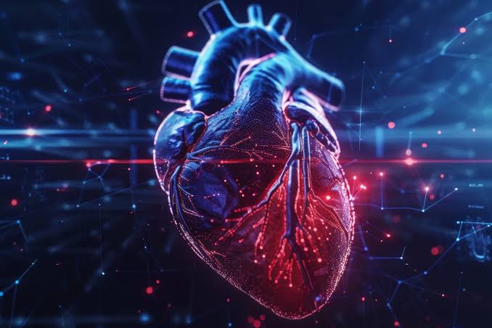
About the Journal:
The Journal of Cardiac Research is an international, peer-reviewed scientific platform dedicated to advancing research in cardiovascular medicine, cardiac biology, and innovative therapeutic approaches for heart diseases. The journal publishes original research articles, clinical studies, reviews, and emerging discoveries covering cardiovascular mechanisms, diagnostics, prevention, and treatment strategies.
The journal provides a multidisciplinary forum for cardiologists, researchers, clinicians, and healthcare professionals to explore advances in cardiac science, including coronary artery disease, heart failure, cardiac imaging, electrophysiology, regenerative medicine, and cardiovascular therapies. It aims to promote scientific collaboration and translate cutting-edge cardiac research into improved patient care and cardiovascular health outcomes.

Latest News:
New Advances in Cardiac Imaging Improve Diagnosis of Complex Heart Diseases:-
Researchers are advancing cardiovascular imaging techniques, including cardiac MRI and non-invasive diagnostic approaches, to improve detection and management of complex heart conditions. Recent studies continue to evaluate how advanced imaging can support personalized treatment decisions and improve outcomes for patients with cardiovascular disease.
Cardiovascular Drug Development Faces Challenges as Inflammation-Based Therapy Trial Fails:-
A late-stage cardiovascular drug trial targeting inflammation pathways in patients with cardiovascular disease and kidney disease did not achieve the expected reduction in major cardiovascular events. The outcome highlights both the challenges of developing new heart therapies and the continued need for innovative approaches in cardiovascular research.

Immune Cells Identified as Key Drivers After Heart Attack Injury:-
New research reveals that immature immune cells released after acute myocardial infarction may influence inflammation, cardiac repair, and long-term patient outcomes. Understanding immune responses after heart injury could lead to improved strategies for preventing heart failure and reducing complications after myocardial infarction.
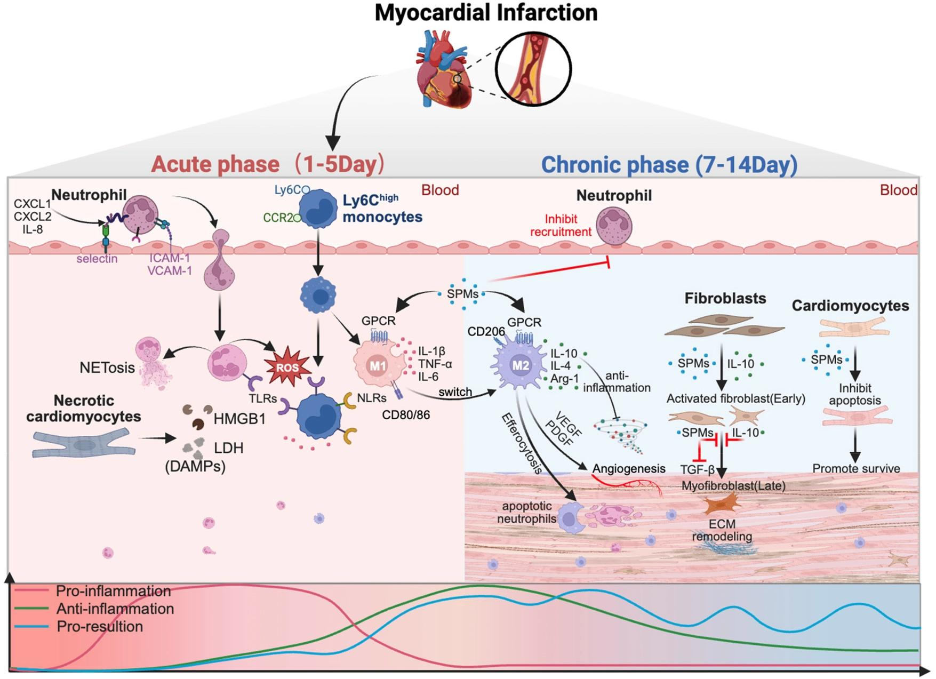

New Genetic Therapy Approaches Advance Cardiovascular Disease Treatment:-
Emerging cardiovascular research is exploring gene-based therapies, including RNA-targeted treatments and genetic interventions, to address inherited and acquired heart diseases. These innovative approaches aim to modify disease pathways at the molecular level and open new possibilities for precision cardiovascular medicine.
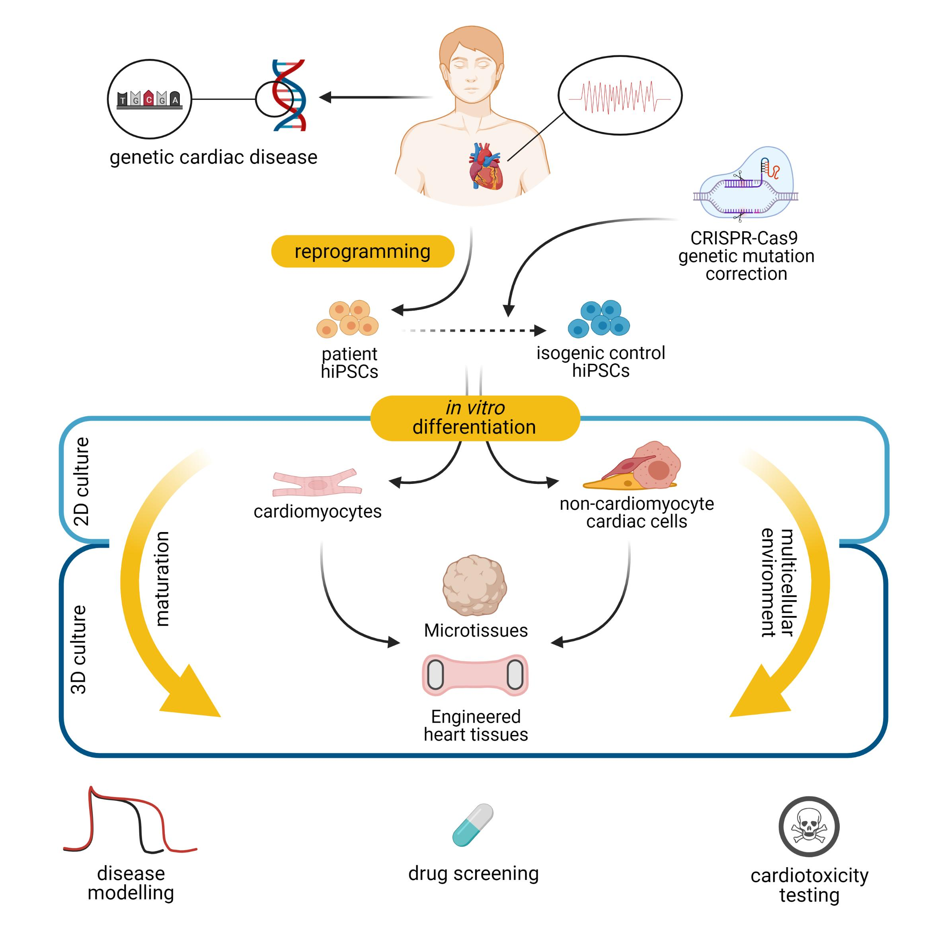

Advanced Cardiac Mapping Reveals New Insights Into Heart Arrhythmias:-
Researchers are combining high-resolution cardiac mapping techniques with advanced imaging approaches to better understand the structural and electrical mechanisms behind dangerous heart rhythm disorders. These discoveries may improve diagnosis, risk prediction, and treatment strategies for patients with arrhythmias.
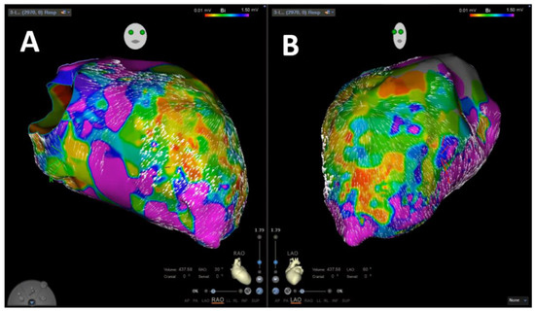

Scientific Topics:

1. Pediatric and Congenital Cardiovascular Disease
Explores congenital heart defects, pediatric cardiac disorders, and advances in diagnosis and treatment of cardiovascular conditions in children. The session highlights innovative approaches in pediatric cardiology, surgical interventions, and long-term care strategies for young patients.
2. Cardiovascular Diseases and Disorders
Focuses on coronary artery disease, vascular disorders, heart rhythm abnormalities, and major cardiovascular conditions affecting global health. The session highlights recent discoveries in disease mechanisms, prevention, and therapeutic approaches.
3. Genetics of Heart & Vascular Disease
Examines genetic mutations, inherited cardiac disorders, genomic medicine, and molecular pathways involved in cardiovascular diseases. The session highlights advances in precision medicine and genetic approaches for improved diagnosis and treatment.
4. Cardiopulmonary Rehabilitation and Prevention
Explores cardiac rehabilitation programs, lifestyle interventions, exercise therapy, and preventive strategies for cardiovascular health. The session highlights evidence-based approaches that improve recovery, quality of life, and long-term outcomes.
5. Diabetes, Hypertension and Obesity
Focuses on metabolic risk factors, hypertension management, obesity-related cardiovascular complications, and preventive interventions. The session highlights strategies for reducing cardiovascular risks associated with chronic metabolic disorders.
6. Geriatric Cardiology
Examines age-related cardiovascular changes, heart diseases in older adults, and specialized approaches for elderly cardiac care. The session highlights personalized treatment strategies that improve health outcomes in aging populations.
7. Cardiovascular Imaging and Analysis
Explores advanced cardiac imaging techniques, diagnostic technologies, and analytical methods for evaluating heart function. The session highlights innovations in imaging that support accurate diagnosis and personalized cardiovascular care.
8. Research and Advances in Cardiology
Highlights emerging discoveries, clinical innovations, and translational research shaping modern cardiovascular medicine. The session explores breakthroughs that improve understanding, diagnosis, and treatment of heart diseases.
9. Diabetes and Cardiometabolic Disease
Focuses on metabolic disorders, insulin resistance, cardiovascular complications, and integrated approaches to cardiometabolic health. The session highlights research strategies for preventing and managing interconnected metabolic and cardiac conditions.
10. Clinical Cardiology
Explores cardiovascular diagnosis, patient management, therapeutic interventions, and evidence-based clinical practices. The session highlights advances that improve patient care and outcomes across different cardiac conditions.
11. Cardiovascular Engineering and Technology
Examines biomedical devices, cardiac technologies, engineering solutions, and innovations in cardiovascular care. The session highlights technological advancements supporting diagnosis, treatment, and monitoring of heart diseases.
12. Neurology and Cardiology
Focuses on the relationship between neurological disorders and cardiovascular conditions, including stroke, vascular disease, and neurocardiac interactions. The session highlights interdisciplinary approaches for managing complex cardiovascular and neurological disorders.
13. Heart Failure and Myocardial Infarction
Explores heart failure mechanisms, myocardial infarction management, cardiac repair, and emerging therapeutic strategies. The session highlights advances in early detection, treatment, and improving survival outcomes.
14. Cardio Oncology
Examines cardiovascular complications associated with cancer therapies, cancer-related heart disease, and preventive cardiac care in oncology patients. The session highlights strategies for balancing effective cancer treatment with cardiovascular protection.
15. Heart Diseases, Treatment and Transplantation
Focuses on advanced treatments for heart diseases, mechanical support systems, and cardiac transplantation approaches. The session highlights innovations improving survival and quality of life for patients with severe cardiac conditions.
16. Cardiovascular Pharmacology
Explores cardiovascular drugs, therapeutic targets, pharmacological mechanisms, and emerging treatment strategies. The session highlights research supporting safer and more effective cardiovascular therapies.
17. Preventive Cardiology
Focuses on risk assessment, lifestyle modification, early intervention, and strategies to prevent cardiovascular diseases. The session highlights approaches promoting heart health and reducing disease burden.
18. Thoracic and Cardiovascular Surgery
Examines surgical techniques, minimally invasive procedures, cardiac operations, and advancements in thoracic care. The session highlights innovations improving surgical outcomes and patient recovery.
19. Womens Cardiovascular Health
Explores gender-specific cardiovascular risks, pregnancy-related heart conditions, and women-focused prevention strategies. The session highlights research addressing unique cardiovascular challenges among women.
20. AI in Cardiology
Focuses on artificial intelligence applications, machine learning, predictive analytics, and digital innovations in cardiovascular medicine. The session highlights how AI is transforming diagnosis, treatment planning, and patient monitoring.
21. Interventional Cardiology and Radiology
Explores catheter-based procedures, vascular interventions, imaging-guided treatments, and minimally invasive cardiac therapies. The session highlights advances improving precision and outcomes in cardiovascular interventions.
22. Cardiovascular Diagnosis & Cardiac Devices
Examines diagnostic methods, wearable technologies, implantable devices, and monitoring systems for cardiovascular care. The session highlights innovations that enhance disease detection, treatment, and patient management.
Editorial in Chief:
Ioana Dumitru
Tampa General Hospital/University of South Florida, Tampa, Fl, USA
Biography:
Ioana Dumitru is a heart failure and transplant cardiologist, professor of medicine with University of South Florida and currently the Medical Director of MCS Program and Co-Director of Heart Failure Center of Excellence at Tampa General Hospital in Tampa, Florida. She has founded and directed two prior successful heart failure, MCS and heart transplant programs in her career with University of Nebraska Medical Center in Omaha Nebraska as well as Memorial Regional Hospital in Hollywood Florida. She has been involved in national landmark trials and has had multiple presentations and publications in the field of heart failure, MCS and cardiac transplantation.
6 Articles are attached herewith…

